Risk Assessment  For Sleepy Hollow Group  use only | Covid 19 | 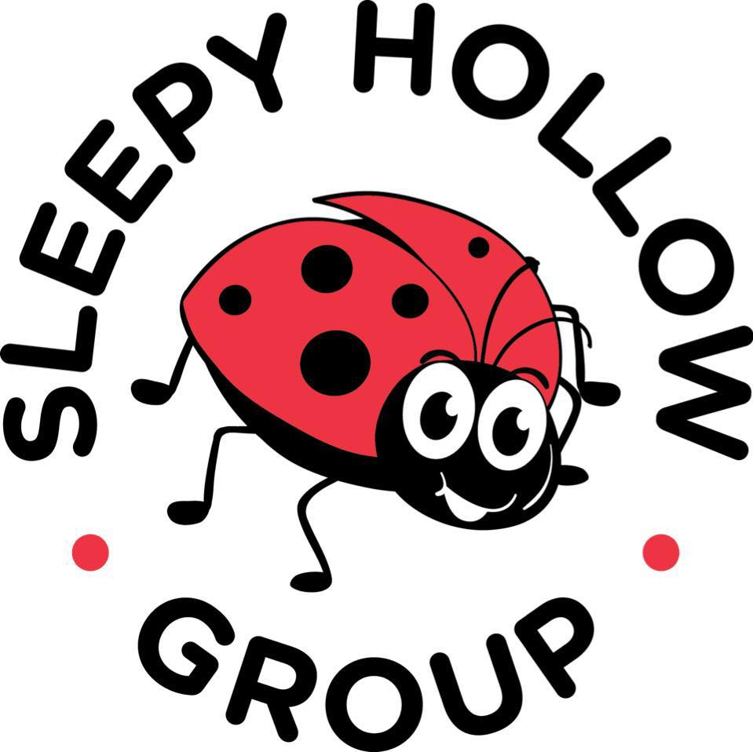
This a live working document and will be subject to changes throughout this pandemic. Any changes will be updated to the policy and updated on our website and famly app as they are made.
Due to the emerging evidence and changes to Government Guidance, it is vital that the most up to date guidance is referred to. This can be found at: https://www.gov.uk/guidance/working-safely-during-coronavirus-covid-19
This risk assessment sets out the controls that will be in place for the workplace and work activities in order to reduce the risk of the transmission of the Covid-19 virus and demonstrate that the Sleepy Hollow is Covid-Secure.

Hazard | Who could be harmed and how? | Existing controls | Risk rating (L x S)
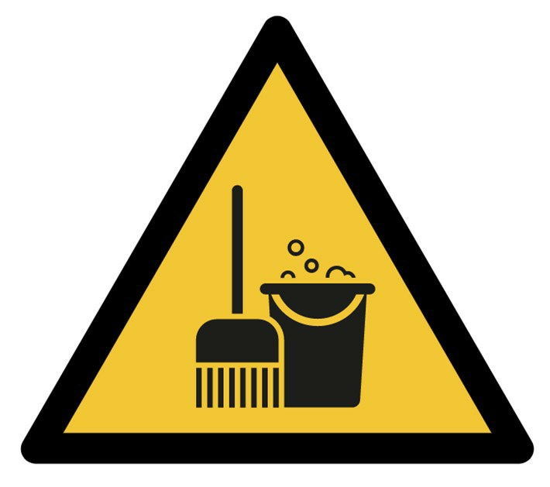  1. Cleaning To Reduce Transmission Of Covid-19  - Risk of exposure to Covid-19 whilst cleaning the setting. | All staff, Contractors  Visitors, Cleaners, Children, Parents  How?  Cleaning areas where Covid-19 may be present may lead to exposure to the virus | 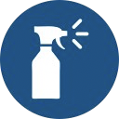 Appropriate Disinfectant Products Used In Line With COSHH Assessment.  Appropriate disinfectant to be used in line with the COSHH assessment - this will be communicated to staff.  The product will be used in line with instructions for use and dilution rates and appropriate PPE provided and worn where indicated.  Disposable cloths will be used where possible to reduce transmission. | 2x5  10  Medium
 | However- the cleaning of all areas correctly will reduce the risk of transmission overall. | 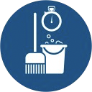 Cleaning Of Setting Before Work Commences  Assessment of cleaning requirements will be carried out prior to the setting opening and appropriate cleaning will take place.  Cleaning Regime For Personal Care In Place  In line with existing policies and procedures for providing personal care to the children - cleaning of changing and toileting areas will be carried out accordingly using the appropriate PPE.  Increased Cleaning Frequency Of Cleaning Throughout Setting  Increased cleaning regime in place throughout setting.  Particular focus on commonly touched areas, equipment, surfaces and common shared areas and food preparation areas and dining areas.  Cleaning materials will be stored safely in line with COSHH assessment for the setting and be available for cleaning toys and equipment used by the children.  Increased Cleaning Of Toys And Play Equipment  Revision of all toys and equipment on site will be carried out.  Toys that are hard to clean such as soft material based items or those with small parts may not be used unless they can be cleaned effectively and regularly.  Easy-clean toys and equipment will be used and cleaned frequently - including after use and at the start/end of the day.  Unnecessary items and equipment will be removed from the rooms where possible.  The Setting Will Be Cleared Of Waste Frequently  Personal items removed at the end of the day and increased waste collection in place in all rooms throughout the setting.
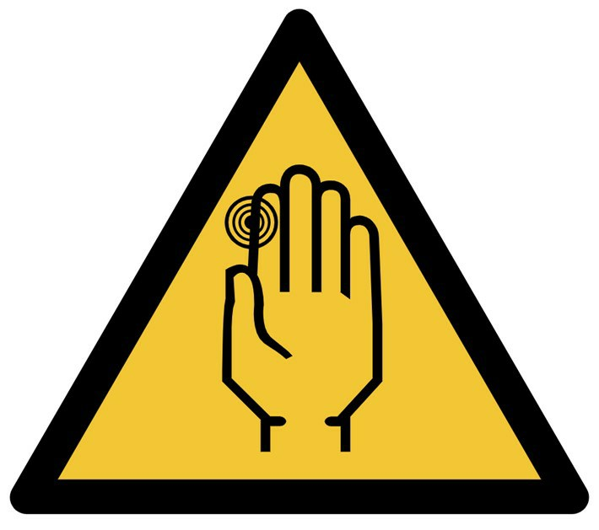  2. Hygiene Control Poor hand hygiene and respiratory hygiene control may lead to an increase in surface contamination. | All staff, Contractors  Visitors, Children, Parents  How?  Increased risk of surfaces becoming contaminated with pathogens including Covid-19 leading to spread of infection. | Employees Advised To Wash Clothing After Work  Employees advised to launder clothes as soon as is possible when they return home. Staff in ECC to change clothes on arrival and when leaving setting  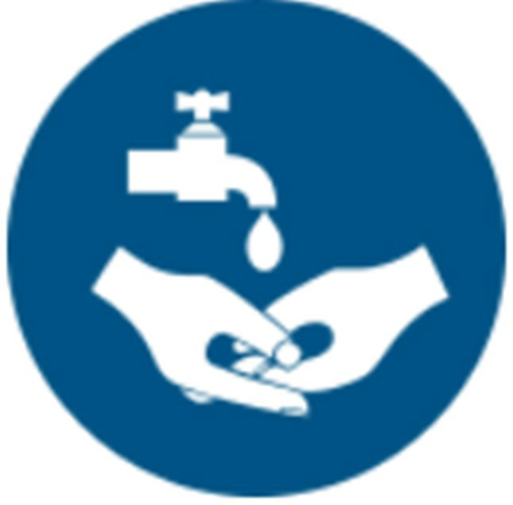 Good Hand Hygiene Established With Children  Through use of songs, games, posters and age-appropriate resources, the children will be encouraged to carry out regular hand washing as part of the daily routines.  All children will be required to wash hands / sanitise upon arrival.  Good Respiratory Hygiene  Staff and children to practice good respiratory hygiene with immediate disposal of tissues into the bin with regular collections.  Through games, songs and age-appropriate resources children will be supported to carry out good hygiene when they cough or sneeze.  High Standards Of Food Safety Standards In Place  In line with existing food safety and hygiene standards for the setting, there will be high standards of hygiene at all times.  This includes hand washing, cleaning of deliveries upon arrival, cleaning of utensils and plates etc.  There will be limited movement of people to issue food with the same person delivering the food to the rooms to the designated drop off location to avoid mixing with the groups and staff in the rooms.  Food preparation and dining areas will be subject to thorough cleaning.  Increased Hand Washing Facilities Provided  Increased hand washing facilities provided throughout the  setting.  Where this is not possible sanitiser will be provided - at entrances, exits, in each room and in common areas.  Increased Waste Management  Additional waste facilities will be available throughout the setting with more frequent collections and removal - especially in changing and toileting areas for the children.  Laundering Of Items Carried Out  Nursery items will be laundered in accordance with DOH laundry guidelines: -Wash items in accordance with the manufacturer’s instructions.  -Use the warmest water setting and dry items completely. -Dirty laundry that has been in contact with an unwell person can be washed with other people’s items.  -Do not shake dirty laundry, this minimises the possibility of dispersing virus through the air.  -Clean and disinfect anything used for transporting laundry with your usual products.  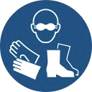 PPE Stock Managed  In order to maintain the correct stock for PPE for personal care, cleaning etc PPE stock will be carefully monitored and managed.  Contingency plans will be in place for replenishing stocks, use of reusable items that can be laundered correctly such as tabbards.  Signs And Posters In Use To Remind To Practise Good Hygiene  Relevant posters and signs displayed to remind employees of the need to wash hands for at least 20 seconds on a frequent basis.  Also signs to remind employees to practice good respiratory hygiene - catching of coughing and sneezes and correct disposal of tissues followed by hand washing.  Use Of Face Coverings  If employees choose to wear face coverings then they will be supported in the workplace.  Face coverings will be used during pick up and handover times or when staff are out of the building on staff related duties such as shopping on or walks. | 2 x 5  10  Medium
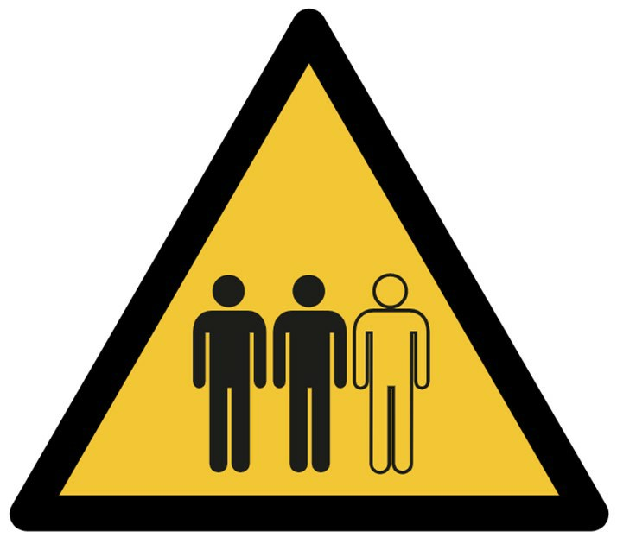  3. Movement Of People In The Setting (Including Employees, Parents and Children) -The attendance of people in the setting will increase the number of people in the premises which may increase the risk of Covid-19 transmission. | All staff, Contractors, Members of the public  Visitors, Children and Parents  How?  Increased risk of transmission of Covid- 19. | Controlled Movement Of People Throughout The Setting.  Use of one way systems, separate entrances and exits to reduce the number of people at cross over areas and pinch points.  Monitoring and regulation of higher traffic areas such as corridors, entrances and stairwells.  Use of signs and markings to indicate the direction of movement and 1m distances in place where appropriate.  Emergency Plans Updated And Communicated  People do not have to adhere to the 1m social distancing where there is an emergency such as fire, an accident or a security threat or break in and the risk to safety is imminent.  Those assisting others in emergencies should ensure they carry out stringent hygiene control afterwards including thorough handwashing.  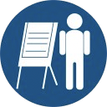 Information, Instruction and Training Provided To Employees  Employees consulted on risks and controls in the work place.  Staff communicated with on a regular basis on changes to hazards and controls.  Employees receive training through the use of training courses, posters, signs, announcements and briefings.  This will include Covid-Specific training and further support for hygiene and infection control.  Minimal Employees To Attend The Setting.  Work organised so that minimal people are required to attend the setting (maintaining the required ratios for safety) whilst supporting social distancing.  Where possible this will be limited to the same people to prevent mixing of groups.  Staff will be grouped for working patterns where possible to avoid the mixing of groups.  Outings Stopped Where Possible  Outings to public settings will be avoided where possible unless it is required to access open spaces that the setting does not have.  This will be limited to areas where social distancing can be maintained.  Restrict Movement Of Employees Throughout The Setting  Employees discouraged from carrying out non-essential trips within the premises- use of phones, emails or radios to communicate with others elsewhere.  Staff to remain working in their designated room and not mix with other rooms or other groups and not access other areas such as office or kitchen where possible.  Drop off and collection areas designated for exchanging of documents, materials, or equipment.  Job rotation reduced to prevent moving between locations where at all possible. Staff not to rotate between rooms.  Restriction On The Movement Of Children And Parents Throughout The Site  Children to be grouped in cohorts / 'bubbles' who do not mix during the day.  Groups to remain fixed where at all possible to prevent mixing.  Groups remain in their room and do not rotate to other rooms.  Where possible these groups will eat and toilet in their own rooms away from the other groups.  Outside spaces that may be shared - will be shared at different times with cleaning of equipment and surfaces in between.  Shared use of communal inside areas will be avoided where possible.  Parents to drop off/ pick up the child at setting entrance or door to avoid the need to come into the setting (unless 'settling in' is required to prevent distress).  Only 1 parent to attend where possible.  The same member of staff from that grouping to be used where at all possible.  Sleeping Arrangements To Be Organised To Be Socially Distant  Where possible cots and beds will be spaced 1m apart.  Staggered Work Patterns  Working patterns organised to reduce the number of persons on-site at any one time and also staggered to reduce the number of people arriving and leaving to prevent cross over at setting entrances, locker rooms and staff rooms.  Cohorts or Teams to be fixed where possible to prevent mixing of different people on shifts.  Touch-based Devices Disabled Where Possible  Where this does not introduce further hazards, touch-based controls/access/security devices will be disabled.  For machines/ equipment that relies on touch screen - this will be limited to as few people as possible with increased cleaning carried out before and after use and hand hygiene practised before and after use.  Use Of Outside Spaces For Breaks Where Possible  Safe outside places will be available for breaks- with social distancing in place through layout and use of signs and markings.  Monitoring of these spaces to be carried out to ensure adherence to social distancing.  Ventilation On Site Increased As Much As Possible.  Windows and doors opened as much as possible to increase ventilation - where this does not increase any risks to the safety and security of the children.  Use of extraction fans may be used to increase ventilation, where safe to use.  Adjustments to be made to ensure adequate ventilation remains in place.  Fire doors will not be propped open.  Guidance on use of Shared Air Conditioning will be taken with a competent engineer.  Vulnerable Persons Protected  Further assessment of the specific risks will be carried out on a case by case basis.  Those classed as clinically extremely vulnerable are advised not to work outside of the home .  Those classed as clinically vulnerable are advised to work 1m away from other persons where they cannot work from home.  For those households where someone is shielding as they are clinically extremely vulnerable and the child is not able to maintain social distancing then they will be discouraged from attending the setting.  Workstations Will Be Organised To Support Social Distancing  for office staff- workstations will be arranged so that social distancing can be adhered to.  Markers or floor plans to demonstrate social distancing. Desks will be spaced out to maintain distance between people.  Hot-desking will be prevented where at all possible- if this is not possible thorough cleaning will take place before and after use of all equipment.  Where possible use of own peripherals such as mouse and keyboards and headsets will be in place.  Where social distancing cannot be maintained further controls will be in place: Desks to allow people to work side by side or facing away from each other. Use of screens to separate people.  Increased cleaning of areas. | 2 x 5  10  Medium
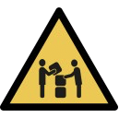  4. Social Distancing Guidelines Cannot Be Met -Activities, where social distancing cannot be followed in full, may lead to increased risk of the transmission of the virus due to being in close proximity. This includes entrances, exits and common areas as well as the main setting. It is recognised that it will be hard to ensure that younger children or those with additional needs may not be able to adhere to social distancing. | All staff  How?  Being in close proximity may lead to increased risk of the spread of the Covid-19 virus. | 1.Increased Cleaning Carried Out  Increased cleaning of surfaces where people are operating within the 1m social distancing to be carried out.  2.Increased Handwashing Carried Out  Provisions will be made in order for people to be able to wash their hands more frequenlty- including before and immediately after carrying out tasks where social distancing has not been maintained.  3.Time Spent Within 1m To Be Kept To A Minimum  The time where persons are within 1m will be kept to as short a time as practicable possible.  4.Physical Barriers or Screens In Use  To screen people from each other physical barriers or screens will be used and cleaned frequently.  5.Employees To Avoid Face To Face Work Where Possible  Where possible employees will work side by side or back to back to avoid working face to face.  6. Staff Teams / Groups Will Be Kept Fixed Where Possible  To reduce the number of different people working within the 1m fixed teams and partners will be place where at all possible to reduce the level of possible transmission  7.Work Activity Will Not Go Ahead  Where social distancing cannot be maintained and cannot be limited to a small group of fixed people then the activity will be assessed to decide if it can go ahead safely.  8. Use of Personal Protective Equipment (PPE)  Additional PPE beyond what is normally worn to control workplace risk, for management of COVID infection has limited benefits and precautionary use of additional PPE for this purpose is not encouraged.  However where the risk assessment identifies high risk transmission due to difficulties implementing controls then PPE will be considered as a further control measure.  Appropriate PPE will be selected and employees trained in its safe and effective use, storage and disposal in line with PPE risk assessments. | 5 x 7  35  High
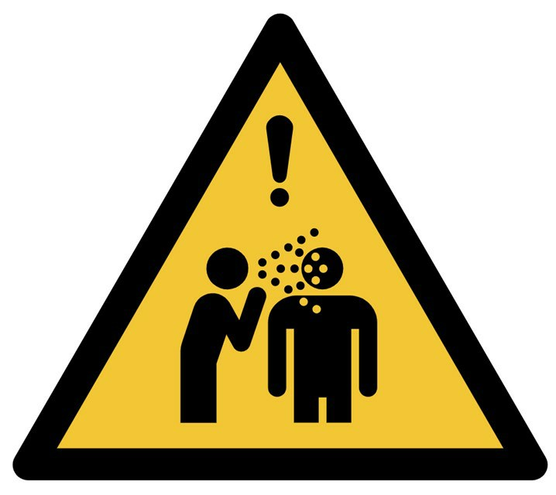  5.Individuals Displaying Symptoms  - Coronavirus reportedly spread through exposure or contact to cough droplets. People developing on-set of symptoms within the setting | All staff, Contractors  Visitors, Children and Parents  How?  An individual could develop symptoms of high/raised temperature or new/continuous cough whilst at work and increased risk of transmission of the Covid-19 virus. | Cases Recorded and Investigated.  Records maintained of those who are isolating or who develop symptoms at the setting.  Investigations carried out if the transmission could be work-related in the event it needs to be reported under RIDDOR.  Appropriate risk assessments and work activities reviewed to ensure there are effective controls or if any changes are required.  Communication With Parents  Setting to communicate with parents on the procedure if anyone in their household has any symptoms that they cannot attend and what the procedure is if someone develops symptoms on site.  Good Hand Washing/Hygiene Procedures Observed  Staff should be carrying out regular hand washing for at least 20 seconds using soap and water or use of a sanitiser if this is not available.  Following cleaning an area after a symptomatic person the hands should be thoroughly cleaned.  Health Status Of People Monitored  Return to setting health questionnaire in place for those children and staff who have been absent.  People Not To Return To The Setting And Should Self-Isolate  For those displaying symptoms of a high or raised temperature or new/persistent cough, isolation should be exercised immediately, ensuring Line Management are informed.  Should individuals live with those displaying symptoms, they should isolate for until they are tested.  Person To Go Home Immediately  The employee will be sent home directly from work and maintain social distancing to do so.  For those such as children who require someone from their household to come and pick them up - they will wait in an isolated room away from anyone else until they are collected.  Any windows will be kept open to increase ventilation.  Any person waiting with the symptomatic person should be from their group and PPE may be considered if 1m distance cannot be maintained.  This area will deep cleaned and sanitised using our fogging machines in accordance with the guidance, with the person then carrying out through hand hygiene afterwards.  Persons with symptoms should not be attending the nursery to pick up or drop off children.  Positive Tests Will Trigger Self Isolation For Group  Where a staff member or child tests positive for Covid-19 the rest of the room/ group will be sent home and advised to self isolate for 14 days. (Follow our policy/guidance on this)  The local public health team will be consulted for further required action in the event of positive tests confirmed for the setting.  Waste Disposed Of With Care With Local Guidelines.  Any waste from areas where symptomatic people have worked- including the PPE and cleaning items that have been used will be double-bagged and labelled and disposed of 72 hours with normal collection arrangements - or if test results come back negative where applicable.  If unable to store the waste then arrangements for clinical waste collection will be made.  Will Follow Government Advice On Testing  https://www.gov.uk/guidance/coronavirus- covid-19-getting-tested  Staff and children are entitled to request a test if they develop symptoms.  Work Area Cleaned Thoroughly Using Disinfectant Following Guidelines.  https://www.gov.uk/government/publications/covid-19-decontamination-in-non- healthcare-settings/covid-19-decontamination-in-non-healthcare-settings  If dealing with bodily fluids or suspected Covid-19 person then extra precautions will be needed which will include protection for eyes, fluid-resistant mask in addition to the disposable gloves and aprons.  For disposal these should be then double-bagged and labelled and stored safely and securely for 72 hours before disposal by normal means of collection.  Staff will be trained in the effective use of PPE to ensure it offers the correct level of protection. | 4 x 6  24  Medium
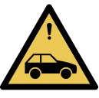  Coming To Work And Leaving Work  - Sharing of a vehicle to, from work or use of public transport may lead to an inability to maintain social distancing | All staff, Members of the public  How?  Exposure to the virus due to inability to maintain social distancing leading to potentially contracting the virus. | Safer Travel Supported  Car sharing with people from different households will be discouraged.  Alternatives such as walking and cycling will be supported with increased facilities.  Use of Public Transport will be discouraged and where it cannot be avoided- current guidance should be followed.  Shifts Staggered  Where at all possible shifts will be staggered to allow employees to travel outside of rush hours as well as staggering arrival and departure times to avoid cross over at staff rooms, locker rooms and exits. | 2x5  10  Medium
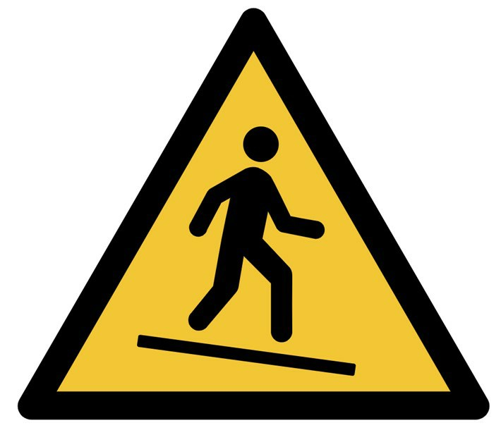  Common Areas (Including Kitchen and Welfare Facilities and Entrances To The Setting). - Due to areas being frequently utilised, the potential for infection is increased. This includes stairwells, waiting areas, seating areas as well as toilets, changing room and kitchen areas. This also includes entrance areas such as foyers, porches and hallways where people arrive and leave. | All staff, Contractors  Visitors, Children and Parents  How?  Common areas may restrict distancing of  2+ metres at any one time. Due to heavy foot fall, surfaces may be touched more frequently and individuals may cross paths more often. This increases the risk of transmission of Covid- 19 virus. | Access To Toilets / Showers/ Changing Rooms Controlled  Restrictions on the number of people using facilities at any one time to allow for social distancing.  Use of markings and posters to indicate the social distancing requirements. Staff to support the children to maintain social distancing when toileting.  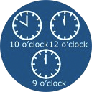 Break Times Staggered And Employees Remain On Site  Employees to remain on site where possible during breaks.  Break times to be staggered to prevent the gathering of people. Staff working part time shifts to minimise need for use of staff room.  Increased Frequency Of Cleaning Of Toilets / Changing Rooms and Kitchens.  Increased cleaning of the welfare facilities will be carried out on-site- including changing areas, staff toilets and children's toileting facilities.  Increased frequency of cleaning of kitchen facilities to be carried out. Employees to clean kitchen items before and after use.  Numbers Of People In Common Areas Managed.  Individuals using common areas will be kept to a minimum at all times and social distancing will be strictly adhered to.  Pro-active Monitoring In Place  Common areas, including toilets and access and egress routes are monitored frequently, ensuring individuals are exercising social distancing.  Regular Cleaning Of Common Area And Touch Points.  Common areas where people pass through are to be cleaned frequently but specific attention to be paid to areas where people spend more time or common touchpoints.  These will be cleaned more intensely/frequently.  The appropriate disinfectant will be used in line with the COSHH Assessment and the correct PPE worn which will be disposed of correctly.  Disposable cloths will be used where possible to reduce transmission.  Staff Room And Kitchen Facilities Restricted  Staffroom and kitchen access restricted to limit the number of people permitted at any one time.  Employees encouraged to bring in own food to avoid the need to use facilities.
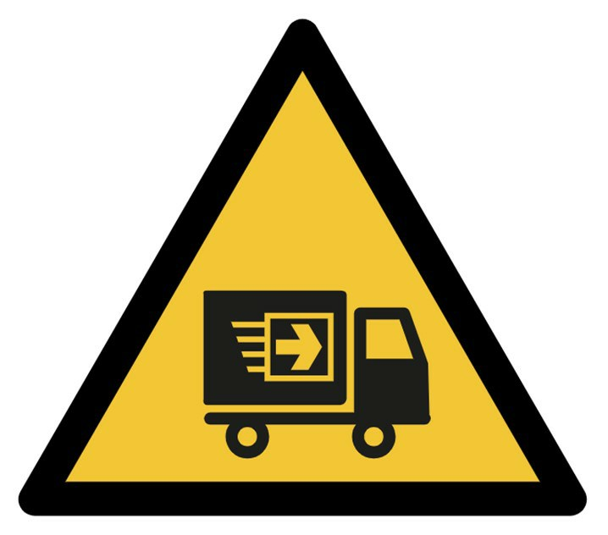  Handling Items, Materials And Using On-Site Vehicles.  - Employees occupying work vehicles at the same time or shared use of common items, toys and | All staff, Contractors  Visitors, Children and Parents  How?  Inability to maintain social distancing or coming into contact with contaminated surfaces may lead to contraction of the Covid-19 virus. | All Items To Be Cleaned Regularly  Any goods or items entering the site will be cleaned using appropriate cleaning products.  All commonly used equipment such as laptops, tablets, toys, play equipment and resources to be cleaned regularly.  Good Hand Washing/Hygiene Procedures Observed Before and After Use  All employees to wash hands for 20 seconds with soap and water or use sanitiser, before and after handling any equipment or materials or before and after using any work vehicles.  Children to wash hands after handling shared toys and resources and discouraged from placing near the face.  Items Not Shared  Personal items such as blankets, flannels, towels and bedding will not be shared between children - allocated own materials for use.  Food and utensils will not be shared.  Items Not Shared Between Rooms  Where possible each room will have its own resources, toys, equipment and items to prevent the need to share between rooms.  Mitigation Of Risk For Employees Travelling And Working Together  Workplace transport such as work minibuses will have limited persons permitted.  Children who are old enough to put on and take off their own masks will wear these on any school runs. We have dedicated vehicles and staff per school run. Windows to be kept open during travel to improve ventilation. Vehicles will be cleaned between use and valeted once per week for a deep clean  Non-Essential Deliveries Not Permitted  Non-business deliveries to workplace will be discouraged - such as personal items being delivered to work.  Non-essential Travel Prevented  Journeys will not be made where at all possible and work carried out remotely.  Personal Items Not Permitted On Site  Where possible personal items such as prams, car seats, and toys will not be brought from home and left at the setting. We will allow comforters and dummies.  Where personal items are absolutely essential they will be thoroughly cleaned upon arrival.  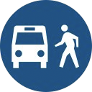 Vehicles Not Shared Where At All Possible  Where the job permits, vehicles will not be occupied by more than one person at any one time.  Where possible the same person will use the same vehicle and not swap with other drivers.  If vehicles are to be used by different people at different times then they will be cleaned before and after each use.  Vehicles taken home by employees will be cleaned before the next person uses it. | 2 x 5  10  Medium
Managing Parents, Visitors and  Contractors Coming To Site. - Parents, tradespeople, couriers, deliveries, contractors and other visitors attending site. | How?  Transmission of Covid- 19 between visitors to site and employees.  All staff, Contractors & Visitors | 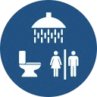 Access To Welfare Facilities Controlled  Access to welfare facilities is strictly controlled with increased cleaning carried out and use monitored.  All Visitors To Site To Be Pre-Arranged And Times Staggered  Non-essential visitors/contractors to be requested or permitted on site.  No unauthorised visitors to be permitted on site- they will be turned away until correct arrangements made.  Visitors to be allocated specific time slots and staggered to reduce the number of people on site.  Where possible visitors and contractors will be arranged to attend outside of setting opening times when less staff and no children will be on site.  Documentation Issued Electronically Where Possible  To reduce the need to exchange paperwork and other documents, the information will be exchanged electronically instead where at all possible.  Good Hand Washing/Hygiene Procedures Observed By Employees  Employees to wash hands for 20 seconds with soap and water regularly and have access to sanitsier where this is not possible- before and after any interaction with others. | 3 x 5  15  Medium
Increased Cleaning Regime In Place For Touch Points And Interfaces.
Increased cleaning of areas where there are interactions with others not from the workplace will be carried out. This includes waiting areas, handles, handrails, counter tops.
Information Communicated To Visitors To Site
Prior communication issued to expected visitors to site through phone, email or website.
Information signs displayed at visitor arrival areas to make procedures clear.
Managed Entry
The number of people permitted inside the premises will be restricted to allow effective social distancing.
There will be the use of effective queue management outside the premises where necessary,
The entrance/ exit points for contractors/ visitors etc will be away from employee areas where possible to minimise contact with other people.
Parents will be advised of the procedure for pick up and drop off to avoid them congregating at the entrances. This may include markings on the floor, one way systems or asking them to wait in their vehicles.
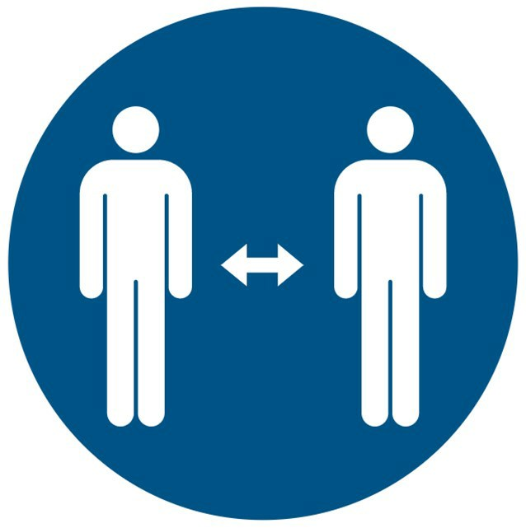 Protective Interface Established
Use of markings, signage and potential use of screens (existing or temporary plexi-glass) to provide a barrier between a visitor to site and employee.
Use of Telcom at the entrance to avoid the need for staff to open doors to speak to visitors.
Remote Communication Encouraged
Where possible remote communication with visitors, parents and contractors will be used rather than attendance on site.
Revised Pick Up and Drop Off Procedures For Deliveries
Designated areas for non-contact deliveries will be in place with clear instructions for couriers.
Revised delivery / collection methods to reduce the number of visitors to the site such as bulk drop-offs and pick-ups to reduce frequency of visitors.
Limited people to carry out the collection of deliveries.
Sanitiser Available At Visitor Interfaces.
Sanitiser available at locations where contractors / visitors will present to employees.
Supervision On Site
Where contractor tasks are required to be supervised- social distancing will be maintained. The host person on site will be aware of their responsibilities to support social distancing and informing the contractor of their requirements.
Visitor Records Maintained
Records of those who have attended site to be maintained where possible.
If requiring people to sign in - pens will not be provided to reduce the need to share equipment.
Touchscreen sign-in systems will be disabled where possible - if not possible then cleaning and sanitising product will be located adjacent to the device.
Waiting Area For Visitors / Contractors Well Managed
Any waiting area for people on site will allow for adequate social distancing outside the door of the premises.
Use of signs and markers and announcements to remind any visitors of the requirements.
Entry to waiting area restricted if the number of people will restrict the ability to socially distance.
People may be turned away until a more suitable time is available where social distancing can be managed.

Meetings  People coming together in close proximity to attend meetings. | All staff, Contractors Visitors  How?  Increased risk of transmission of Covid 19 | Meetings Carried Out Remotely Where Possible  Where possible meetings will be carried out remotely to avoid the need for people to come together.  Meeting to be held outside where possible.  If not then meetings will be held in well-ventilated rooms where windows or doors can be open or use of extractor fans to support ventilation.  No Sharing Of Equipment Permitted  No items are to be shared at any time during the meetings such as pens, computers etc.  Sanitiser To Be Provided  As well as handwashing before and after the meeting, hand sanitiser will be provided for use for meeting participants.  Social Distancing To Be Maintained  All participants to be reminded prior to meeting of the need to adhere to social distancing at all times.  Desks and chairs will be arranged to support social distancing or meeting will be held stood up.  Signs and markings to be used in regular meeting spaces to indicate 1m distances. | 10  Medium  2 x 5
Shared Workspaces With Other Organisations Sharing of premises with other employers, organisations or contractors. | All staff, Contractors, Members of the public  Visitors, Children, Parents  How?  The activities of other people in the premises may lead to variations in the level of controls in place which may increase the risk of transmission of the Covid-19 Virus. | Communication and Cooperation With Others Occupying Premises (Including Landlords)  There will be effective communication between any other employers, organisations or contractors in shared premises to ensure there is cooperation on the controls in place to reduce transmission.  Increased Cleaning Arrangements In Place  A coordinated approach to increased frequency of cleaning of surfaces in common and shared areas such as stairwells, toilets, kitchen facilities.  Increased Hand Washing  Supporting of increased handwashing through the provision of facilities such as additional wash stations or provision of sanitiser where this is not available.  Staggered Break Times With Other Organisations In Premises  To reduce the number of people from differing organisations accessing canteen or welfare facilities or using stairwells and corridors at the same time. | 3x5  15  Medium
In the context of COVID-19 this means working through these steps in order:
In every workplace, increasing the frequency of handwashing and surface cleaning.
Where working from home is not possible, workplaces should make every reasonable effort to comply with the social distancing guidelines set out by the government (keeping people 1m apart wherever possible).
Where the social distancing guidelines cannot be followed in full, in relation to a particular activity, businesses should consider whether that activity needs to continue for the business to operate and if so, take all the mitigating actions possible to reduce the risk of transmission between their staff.
Further mitigating actions include:
• Increasing the frequency of hand washing and surface cleaning.
• Keeping the activity time involved as short as possible.
• Using screens or barriers to separate people from each other.
• Using back-to-back or side-to-side working (rather than face-to-face) whenever possible.
• Reducing the number of people each person has contact with by using ‘fixed teams or partnering’ (so each person works with only a few others).
• Finally, if people must work face-to-face for a sustained period with more than a small group of fixed partners, then you will need to assess whether the activity can safely go ahead.
• No one is obliged to work in an unsafe work environment.
Taken From: https://www.gov.uk/guidance/working-safely-during-coronavirus-covid-19
Safe Use Of Face Coverings
• Wash your hands thoroughly with soap and water for 20seconds or use hand sanitiser before putting a face-covering on, and after removing it. • When wearing a face covering, avoid touching your face or face covering, as you could contaminate them with germs from your hands.
• Change your face covering if it becomes damp or if you’ve touched it.
• Continue to wash your hands regularly.
• Change and wash your face covering daily.
• If the material is washable, wash in line with manufacturer’s instructions.
• If it’s not washable, dispose of it carefully in your usual waste.

Risk ratings are calculated by considering the likelihood of an event occurring along with the severity of the potential consequence should an accident occur. After considering existing control measures, values are assigned to the likelihood and severity from the scales below and these figures multiplied to established the risk rating.
Highly unlikely Likely Highly likely
1 5 9
No injury Minor injury/harm Fatality
What do your risk ratings mean?
Risk is categorised as
LOW: Look to reduce risk if practicable
MEDIUM: Begin to plan your action to reduce the risk immediately Risk has been categorised as
HIGH: Immediate action required to reduce the risk
